Augmented Entities in Real World for E-Learning

1st Ravi Teja Rapolu  
Department of Electronics and Communication Engineering.  
*Vardhaman College Of Engineering affiliated to JNTUH*Hyderabad, India  
rapoluravi_18ec@vardhaman.org

2nd Madhavaram Krishna Gopal  
Department of Electronics and Communication Engineering.  
*Vardhaman College Of Engineering affiliated to JNTUH*Hyderabad, Indiamadhavaramkrishna_18ec@vardhaman.org

3rd GAE. Satish Kumar  
Department of Electronics and Communication Engineering.  
*Vardhaman College Of Engineering affiliated to JNTUH*Hyderabad, India  
gaesathi@vardhaman.org

*Abstract*—Virtual reality replaces the real world with a virtual one. a fictitious one However, augmented reality occurs in real time. The new discipline of Augmented Reality brings up new possibilities. in a variety of industries, with education being one of them. Our The study presents a three-dimensional e-learning system. geometries, which makes advantage of augmented reality to make it possible the user's ability to grasp three-dimensional geometry faster and better concepts It makes the students' lives easier. Comprehension of three-dimensional geometry, which can be useful in a variety of situations. When attempting to achieve the same thing in two dimensions, it becomes more challenging. The algorithm creates a three-dimensional object based on the marker and mixes it into real-world footage. The user can manipulate the object using the system. while also allowing him/her to access the virtual buttons the attributes of the item. Given the limited processing capabilities and memory of mobile devices like smartphones, choosing a suitable tracking method is critical for optimizing the performance of mobile AR apps. The detector, descriptor, matcher, and posture estimator are the four key components of AR tracking. Changes in scale, rotation, and lighting According to research, the Fast Retina Key point (FREAK) descriptor is the most appropriate. FREAK takes less time to compute than other greyscale descriptors and is less affected by scale and rotation changes. However, it ignores the crucial color space data. The improved efficiency and robustness of a 128-bit CRH-FREAK descriptor benefit the future development of mobile AR applications that remain invariant to scale, rotation, and lighting changes.

Keywords— Augmented Reality, augment, geometry, Binary Descriptor descriptor, FREAK ;

# Introduction

Augmented reality (AR) is a term that refers to the merging of real-world and computer-generated data (virtual reality), in which computer graphics items are blended into real-time film. As a result, technology works through improving a person's existing experience of reality. A camera captures markers pasted on real-world objects, which are then processed by a computer using image processing methods. A software code looks for the marker in each frame and, if it is discovered, determines the camera's position in relation to the markers. A 3D virtual object is placed on the marker in the real footage once the position has been determined. As a result, when the user watches a real-world video, he sees a virtual 3-D item superimposed on it. As a result, we can define augmented reality as the addition of virtual content to the real world. As a result of this benefit of Augmented Reality, we chose augmented reality to aid the user in comprehending the complex concepts contained in the static form of geometry, where teaching and learning methodologies are still limited to 2D visualisation.

The use of augmented reality can help students better learn 3D geometry. Because it works in 3D, a user will be able to grasp 3D Geometry ideas more quickly and effectively. Math teachers, as well as students taking competitive and school exams, are among the benefactors.

The proposed system intends to provide a web-based app that allows users to employ AR Markers to place artificial and 3D items into the actual world. The suggested method also gives the user the option of deciding where the object should be placed in the actual world. The object will be presented precisely according to the perspective in the original scene once it has been placed in the scene, which is especially difficult in the case of 3D virtual objects. The proposed system also provides a place anywhere method for the selected 3D models.

# LITERATURE SURVEY

In this section, the numerous methods or systems for learning three-dimensional geometry that are currently accessible being discussed.

### 1)**The Conventional Approach:**

### The usage of power point presentations is a frequent way for studying geometry. With the use of a projector, a teacher will display the shape and the operations performed on the shape on the screen, and the pupils will learn from what the teacher says. The teacher might either make films of the procedures to be done on the object or execute them in front of the students. The following are some additional existing systems:

### 2) **Geometry Learning Tool for Elementary with Augmented Reality**:

### This tool helps developers create augmented reality apps by identifying and registering virtual objects in real time. This tool can be used to teach elementary school pupils how to use a protractor to measure angles. Red, blue, green, and lime are the four colours used. These brightly coloured cards serve as markers. The pivot point will be the red card, the target point will be the green and blue cards, and the angle will be measured with the lime card. The pivot point should not shift because it will become the coordinate system's center point. After the web cam recognizes the red marker card, the pupils can now show the web cam the blue or green marker. The intersect line will show from the positive x coordinate if it is a blue marker. The intersect line will appear from the negative x coordinate if it is a green marker. After displaying the intersect line, the learner can now measure the angle between the intersect lines using a protractor. A lime marker is shown to check the validity of their answer. This activates the function that displays the angle measurement on the screen.

### 3)**Pattern Recognition and Augmented Reality Interactive E-Learning System**:

### This is an interactive e-learning system that uses pattern recognition and augmented reality [3]. The technology presents students with realistic audio-visual content while they are learning. Image recognition, colour and polka-dot pattern identification, and This marker should be attached to the tip of a finger that will be used as the mouse cursor to identify the point in the textbook image. When the marker is placed on one of the specified image objects in the textbook, it is enhanced with suitable interactive audio-visual content. This e-learning system has been successfully implemented in elementary school instructional courses.

4) **Multimedia Augmented Reality Interface for E Learning (MARIE):**

MARIE is a strong augmented reality interface that is closely similar to Magic Book [4]. A lightweight Head Mounted Display (HMD), a small camera, and a computer make up the system. To properly compute the real camera location and orientation relative to predetermined marked cards, the system employs part of the AR-capability Toolkit's as well as computer vision techniques. The user is given a custom-built see-through HMD. In order for multimedia information to be combined with the real environment in real time, the user places a set of specified markers on the table and looks at them through the HMD. The teaching material offered to students is separated into relevant units, and each unit has its own marker. This aids users in selecting the appropriate markers for the educational material. It is now up to the teacher to come up with the best learning technique for the kids. That is, in an AR environment, the order in which students should use the markers to see the instructional information.

**Concerns with present systems:**

The following are some of the concerns with the present systems:

### A) In the traditional approach, teachers utilized Power Point Presentations to display shapes and execute various operations on them. As a result, kids are unable to grasp the shapes in the manner in which they desire. Their comprehension is one-dimensional and limited to what the teacher presents on the projector screen. The pupils do not get any hands-on experience with operations.

### B)Sometimes teachers use physical samples of cubes, spheres and other such shapes while teaching, to help students visualize the structure in a 3D space. But it is inconvenient for the teacher to carry the specimens around. It is difficult for the teacher to provide personal attention to the students in a class of approximate 60 students. Hence, it is very rare that a student gets a specimen to himself/herself to analyze and it’s not feasible for every student to get a specimen to himself. This results in inability to perform operations like slicing through the shape, increasing/decreasing dimensions, etc.

C)The Multimedia Augmented Reality System for E-Learning scans a marker from a page and superimposes a virtual 3D image on top of it. This method is outmoded due to its over-reliance on markers. The new technology that will be built will look for and interpret shapes drawn on the page in order to superimpose a virtual image on the object drawn. The fineness of the marker's edges is determined by the intensity of the marker light; if the threshold process is not properly lighted, jagged edges result, making it difficult to discern between contours. The system fails when the marker is obscured by an external object, which is known as occlusion. This system takes longer to create when utilizing OpenGL software to construct as the items must be coded, the same may be done using blender, which speeds up the rendering process.

After considering the shortcomings of existing systems, it was determined to create an e-learning system that uses augmented reality to successfully teach three-dimensional geometry.

# METHODOLOGY

The proposed model is a multi-paradigm application which uses image tracking and ray casting to make the E-learning experience intuitive and immersive.

### Tracking an image marker

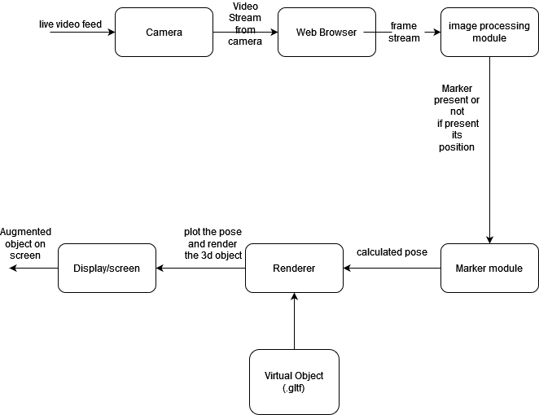

Fig 1: Block diagram of the method that has been proposed

The Fig 1 shows the block diagram in which there is a camera that takes a video and the web-browser accesses the video via navigator API present in the browser, each frame in the video is processed by the image processing module to detect for the marker.

The image processing module takes in each frame and checks for

# conclusion

The existing system of teaching 3D Geometry in schools and universities requires radical reforms, which can be achieved by incorporating technology into every area of our life. Our findings will aid students in developing a thorough comprehension of 3D areas and objects inside them. In this scenario, the usage of Augmented Reality in education is beneficial, as it aids pupils in better understanding the lecture. Our e-learning technology not only gives visual augmented content to students, but it also improves their learning efficiency and concentration. The test is intended to be used as a diagnostic tool for self-study by students. The interface produced using markers is so natural and engaging that it doesn't require any extra training to use the framework The system is user-friendly. As the related videos provided can be revisited any number of times till the student is actually comfortable with the course in question. Thus, improves the learning experience.

##### References